Objectives

General objectives

- To study the effects of diabetes mellitus type II on the Ca²⁺ signaling in in situ endothelial cells of rat aorta.

Specific objectives

- To study the effects of diabetes mellitus type II on the Ca²⁺ signals evoked by ATP
- To study the effects of diabetes mellitus type II on the Ca²⁺ signals evoked by Ach.
- To study the effects of diabetes mellitus type II on the Ca²⁺ signals evoked by endothelium injury.

Material and Methods:

Aorta dissection

In the present work, three strains of male rats were used: Lean Zucker Diabetic Fatty (LZDF), Obese Zucker Diabetic Fatty (OZDF) about 1 year old and Wistar (W) four to six months old. Before the experiment, blood sample was obtained from caudal vein puncture and analyzed to obtain glucose levels with an Accu-Check™ sensor from Roche®. Some rats were anaesthetized with diethyl ether. Toracotomy were performed to locate the heart and upper part of thoracic aorta. The heart was dissected out leaving the aortic arch uncovered. Immediately the aorta was cannulated and perfused with physiological salt solution (PSS). PSS had the following composition (mM/lt): 150 NaCl, 6 KCl, 1.5 CaCl₂, 1 MgCl₂, 10 D-Glucose, 10 HEPES, in Ca²⁺ free-solution CaCl₂ were substituted by 0.5 mM EGTA. PSS was titrate to pH 7.4 with NaOH. Aorta was transferred to a Petri dish with PSS and all the fat and connective tissue remaining was carefully removed. Aorta was cut in rings about 3 mm wide.

Microfluorimetry technique

The aortic rings were opened and incubated in Fura-2 16µM for 90 min at room temperature (20-25°C). Aorta strips were fixed in a Petri dish containing PSS with the lumen face up. In in situ endothelial cells (ECs) were visualized by an upright epifluorescence Axiolab microscope (Carl Zeiss, Germany), equipped with a Zeiss 63X Achroplan objective (water-immersion, 2.0 mm working distance, 0.9 numerical aperture). ECs were excited alternately at 340 and 380 nm, and the emitted light was detected at 510 nm. A first neutral density filter (1 or 0.3 optical density) reduced the overall intensity of the exciting light and a second neutral density filter (optical density = 0.3) was coupled to the 380-nm filter to approach the intensity of the 340-nm light. The exciting filters were mounted on a filter wheel (Lambda 10, Sutter Instrument, Novato, Calif., USA). Custom software, working in the LINUX environment, was used to drive the camera (Extended-ISIS Camera, Photonic Science, Millham, UK) and the filter wheel, and to measure and plot on-line the fluorescence from 7 rectangular regions of interest (ROI), each ROI enclosed a single cell. However, cell borders were not always clearly identifiable so that an ROI might include part of the cytoplasm of adjacent cells. Adjacent ROI never superimposed. Variations in the intracellular Ca²⁺ concentration ([Ca²⁺]_{i}) were monitored by evaluating, for each ROI, the ratio of the fluorescence signal emitted at 510 nm when exciting at 340 and 380 nm, respectively. Ratio measurements were performed every 2.5 s. Ca²⁺ signals were recorded at room temperature (20–25°C), to limit time-dependent decreases in the intensity of the fluorescence signal. For administration of interest agonists the bathing medium was aspired by a suction pump and then adding the desired solution. The medium could be substituted quickly without producing artifacts in the fluorescence signal because a small meniscus of liquid remained between the tip of the objective and the facing surface of the aorta.

Solutions & chemicals:

Adenosine Triphosphate (ATP), Acetyl Choline (Ach) and Fura-2 were bought from Sigma Aldrich. ATP and ACh stock solutions were prepared with deionized water and Fura-2 in DMSO.

Analysis

Data analysis was performed using the programs Microcal Origin 7.0 and Microsoft Excel. Statistical analysis included t-Test and ANOVA. Results are showed as the mean ± standard error. Typical recording correspond to a single cell Ca²⁺ signal. Recordings were filtered using Microcal Origin.
The parameters analyzed in this work were: a) Peak amplitude; calculated as the difference between the highest value of Ca²⁺ transient evoked by the agonist minus the Ca²⁺ basal level. b) The maximum derivative, was calculated using Microcal Origin 7.0. c) Transient duration at 90%, 60% and 30% of the maximal transient amplitude, were obtained as the time in which the transient amplitude decrease by 90%, 60% and 30% respectively.

Results

Physical and metabolic parameters

Body weight was significantly higher in OZDF rats than that in W and LZDF rats. Surprisingly, not significant differences were found in serum glucose levels between OZDF and LZDF rats. No sufficient data from W rats were obtained to do statistical analysis (n=1). (Table 1)

Table 1. Values are the mean ± SE. P<0.01 vs W, § P< 0.001 vs W, P< 0.01 vs LZDF

ATP induced Ca²⁺ signal

In our hands only about 12% of cell from W rats responded to the application of 20μM ATP (9 cell of 74 tested). For that reason, we used 100 µM ATP. ATP 100μM caused a Ca²⁺ signal in in situ ECs from W, LZDF and OZDF rats. The Ca²⁺ signal was compose by a fast increase in [Ca²⁺]_{i} followed by a slow decay to the basal levels (Fig 1). However the number of cells responding to ATP (100µM) were reduced about 40% in LZDF and OZDF compared with W rats (n=57 cells of 112 tested (57/112) for W, n= 37/112 for LZDF and n=39/112 for OZDF). In addition, Ca²⁺ response evoked by ATP was significantly different between W and LZDF rats, two strands of rats considered as lean rats. Peak amplitude, transient duration at 90% and maximum derivative, was reduced in LZDF by 44%, 8% and 10% respectively, compared with W rats (see Table 2). These results suggest that LZDF have impaired endothelial function. As shown in Table 2 we found statistic differences also between the Ca²⁺ response evoked by ATP in OZDF and LZDF rats. The peak amplitude was reduced by 25% and the transient duration at 60% was reduced by 63% in OZDF compared with LZDF rats (see Table 2).
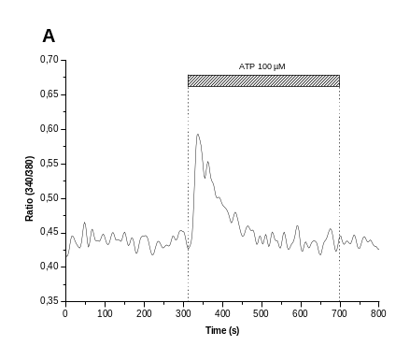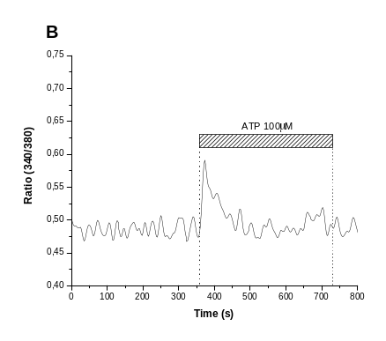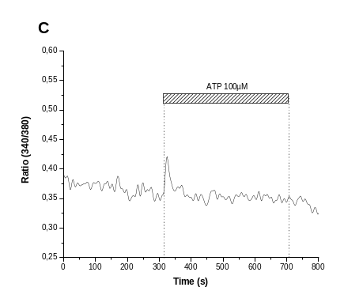
Fig. 1. Typical Ca²⁺ signal evoked by ATP 100µM. (A) Wistar; (B) LZDF; (C) OZDF rats.

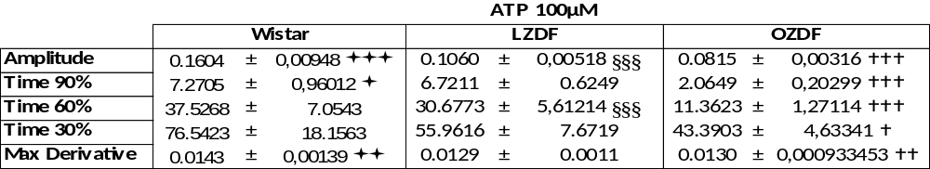

Table. 2. Parameters of Ca²⁺ signal evoked by ATP 100μM. Data are presented as means ± SE; (,§,)P < 0.05; (,§§,)P<0.01; (,§§§,)P < 0.001.  Wistar vs. LZDF; § LZDF vs. OZDF,  Wistar vs.OZDF.

Application of 100 µM ATP in Ca²⁺ free-solution caused a Ca²⁺ signal in in situ ECs of W, LZDF and OZDF rats. In these experiments the Ca²⁺ signal was compose by a fast increase in [Ca²⁺]_{i} followed by a relatively rapid decay to the Ca²⁺ basal levels when compared with Ca²⁺ transient evoked by ATP 100μM in normal extracellular Ca²⁺ (Fig. 2). The number of cells responding to ATP (100µM in Ca²⁺ free solution) was similar in W and LZDF and reduced about 90% in OZDF rats (n=20/49 for W, n= 23/49 for LZDF and n=2/49 for OZDF). The peak amplitude and maximum derivative were reduced significantly in OZDF and LZDF compared with W rats, Table 3. Not significantly differences were found in transient parameters of OZDF compared with LZDF rats. The time to achieve the 90%, and 30% of transient amplitude were similar in all the rat strains, Table 3. The transient duration at 60% had statistical differences in LZDF compared with Wistar and OZDF (see Table 3).
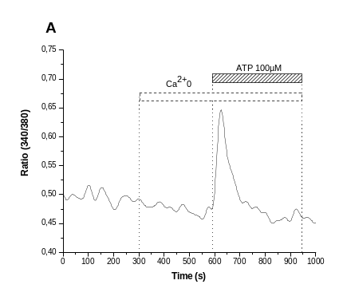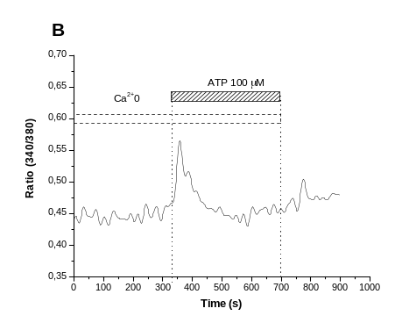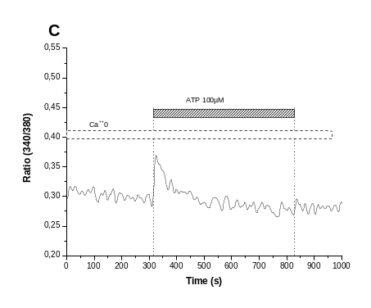
Fig. 2. Typical Ca²⁺ response to the application of ATP (100µM) in Ca²⁺0. (A) Wistar; (B) LZDF; (C) OZDF.

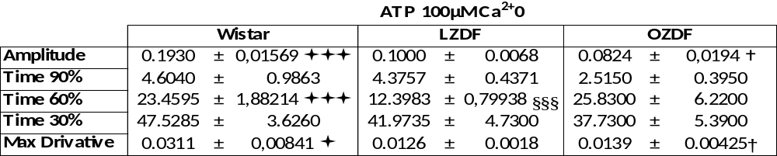

Table. 3. Data mean ± SE ATP 100µM Ca²⁺0. Data are presented as means ± SE; (,§,)P < 0.05; (,§§,)P<0.01; (,§§§,)P < 0.001.  Wistar vs. LZDF; § LZDF vs. OZDF,  Wistar vs. OZDF.

To characterize in more detail the Ca²⁺ signal evoked by ATP, we applied, a high ATP concentration (300µM). In this case, the Ca²⁺ signal evoked by ATP in endothelial cells from Wistar rats was compose by a fast increase in [Ca²⁺]_{i} followed by a plateau, (Fig 3). The number of cells responding to ATP (300µM) was higher about 20% in OZDF compared with W and LZDF rats (n=29/91 for W, n= 30/91 for LZDF and n=36/84 for OZDF). The Ca²⁺ transient peak amplitude was reduced in OZDF compared with W and LZDF rats, no statistic differences were found between W and LZDF rats peak amplitude (Table 4). Interestingly the transient duration was reduced by 62% in LZDF and by about 50% in OZDF compared with W rats (Table 4).
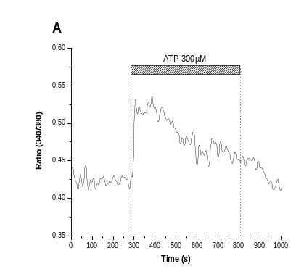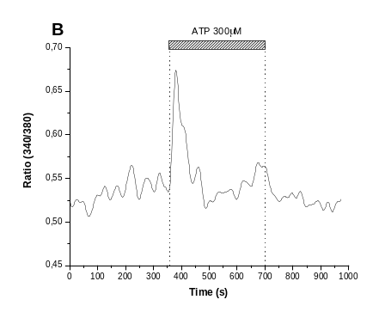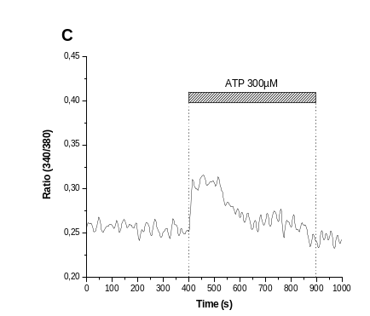
Fig. 3. Typical response to ATP 300µM. (A) Wistar; (B) LZDF; (C) OZDF. Images has FFT filter from Microcal Origin 7.0.

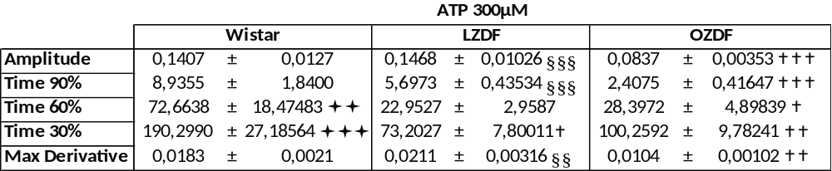
Table. 4. Data mean ± SE ATP 300µM. Data are presented as means ± SE; (,§,)P < 0.05; (,§§,)P<0.01; (,§§§,)P < 0.001.  Wistar vs. LZDF; § LZDF vs. OZDF,  Wistar vs. OZDF.

ACh induced Ca²⁺ signal

Application of 1µM ACh caused calcium signal in in situ ECs only from W rats. The calcium signal was compose by a fast increase in [Ca²⁺]_{i} followed by long duration plateau. (Fig 4). For W rats 8/14 cells respond to ACh (1µM), (n= 0/14 for LZDF and n=0/14 for OZDF). Peak amplitude was 0,10571±0,01628, and its maximum derivative 0,0198±0,0137. The time to achieve the 90%, 60% and 30% of amplitude was: 17.06 ± 5.79, 189.08 ±46.12 and 569 ± 164 ms respectively.
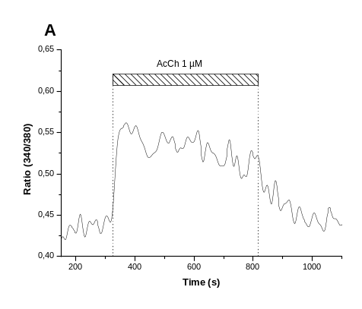
Fig. 4. Typical response to ACh 1 µM. (A) Wistar; (B) LZDF (no response); (C) OZDF (no response).

Application of 10µM ACh caused calcium signal in in situ ECs in W and OZDF rats. The Ca²⁺ signal was compose by a fast increase in [Ca²⁺]_{i} followed by a long duration plateau. (Fig. 5). The number of cells responding to ACh (10µM) were lower about 60% in W compared with OZDF rats (n=3/35 for W, n=0/35 for LZDF and n=12/35 for OZDF). Peak amplitude was significantly higher in OZDF compared with W, Fig 5, Table 5. Maximum derivative indicates that the response velocity is higher in OZDF than in W rats (W rats maximum derivative=0,0068±0,0016, P < 0.05 vs. OZDF; and OZDF 0,0201±0,0021) Table 5. The largest plateau was found in W rats, while the time to achieve the 90%, 60% and 30% of amplitude was smaller in OZDF as shown in Table 5.
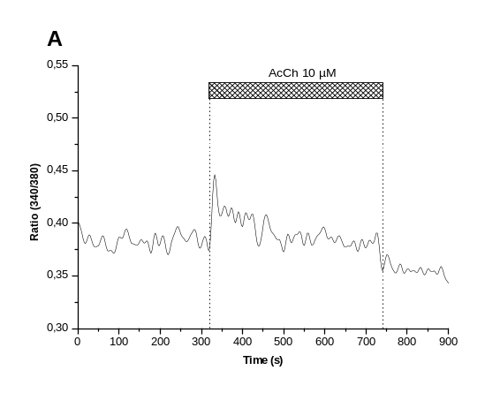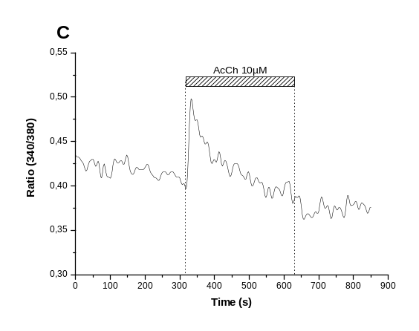

Fig. 5. Typical response to ACh 10µM. (A) Wistar; (B) LZDF (no response); (C) OZDF.

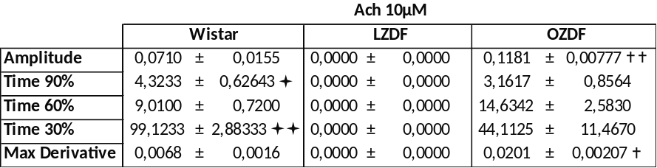

Table. 5. Data mean ± SE ACh 10µM. Data are presented as means ± SE; (,§,)P < 0.05; (,§§,)P<0.01; (,§§§,)P < 0.001.  Wistar vs. LZDF; § LZDF vs. OZDF,  Wistar vs. OZDF.

Application of 100µM ACh caused calcium signal in in situ ECs in W, LZDF and OZDF rats (Fig. 6). The number of cells responding to ACh (100µM) were near the double in OZDF compared with W and LZDF rats (n=14/105 for W, n= 10/105 for LZDF and n=20/105 for OZDF). Peak amplitude was also higher in LZDF compared with W and OZDF rats, Table 6. Maximum derivative had no significantly difference between rat strains Table 6. The largest plateau, determined by the time to reach amplitude 30% is found in LZDF rats, as shown in Table 6.

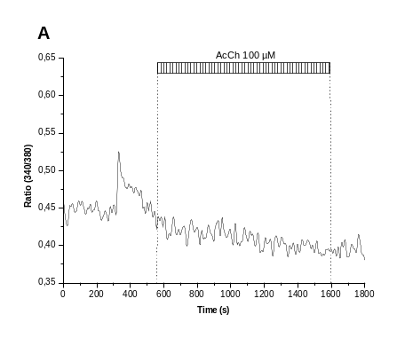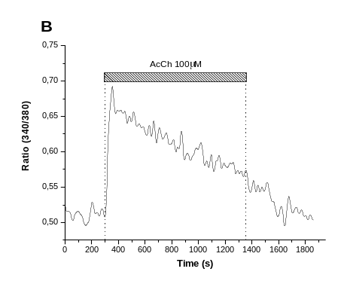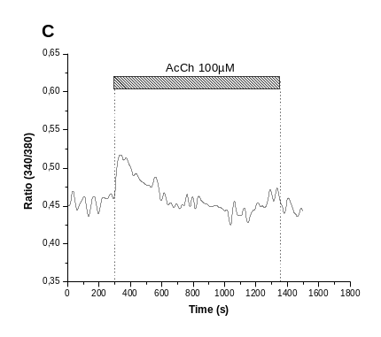

Fig. 6. Typical responses to ACh 100µM. (A) Wistar; (B) LZDF; (C) OZDF. Images has FFT filters from Microcal.

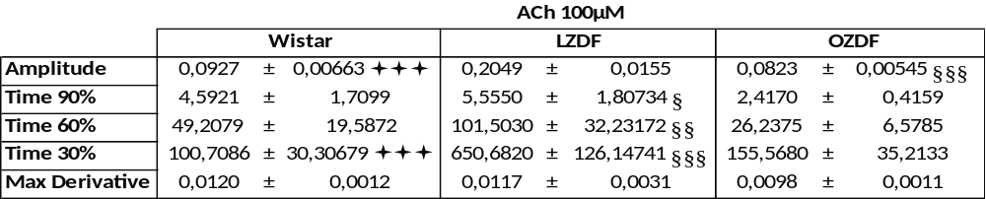

Table. 6. Data mean ± SE ACh 100µM. Data are presented as means ± SE; (,§,)P < 0.05; (,§§,)P<0.01; (,§§§,)P < 0.001.  Wistar vs. LZDF; § LZDF vs. OZDF,  Wistar vs. OZDF.

Mechanical injury induced Ca²⁺ signal

Mechanical injury in in situ endothelium, caused a Ca²⁺ signal in W LZDF and OZDF rats. We are analyzing the patterns of Ca²⁺ signal in W rats. We detected three different patterns: Type 1, peak and Plateau (Fig 7A); Type 2, peak and decay to the Ca²⁺ basal levels (Fig 7B); Type 3, peak, and oscilations (Fig 7C). Preliminary results indicated that in LZDF and OZDF the principal response is similar to type 2 responses, no plateau is observed. More experiments are needed to confirm it.
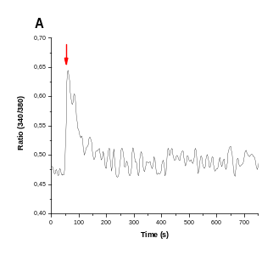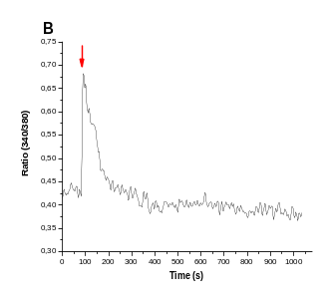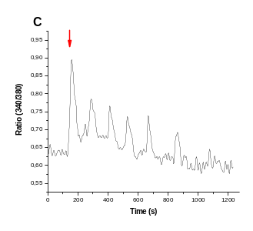
Fig. 7. Typical responses to injured endothelium. (A) Type 1: peak; (B) Type 2: peak and plateau; (C) Type 3: peak and oscillations. Arrows indicate injured time.

